Name: ______________________
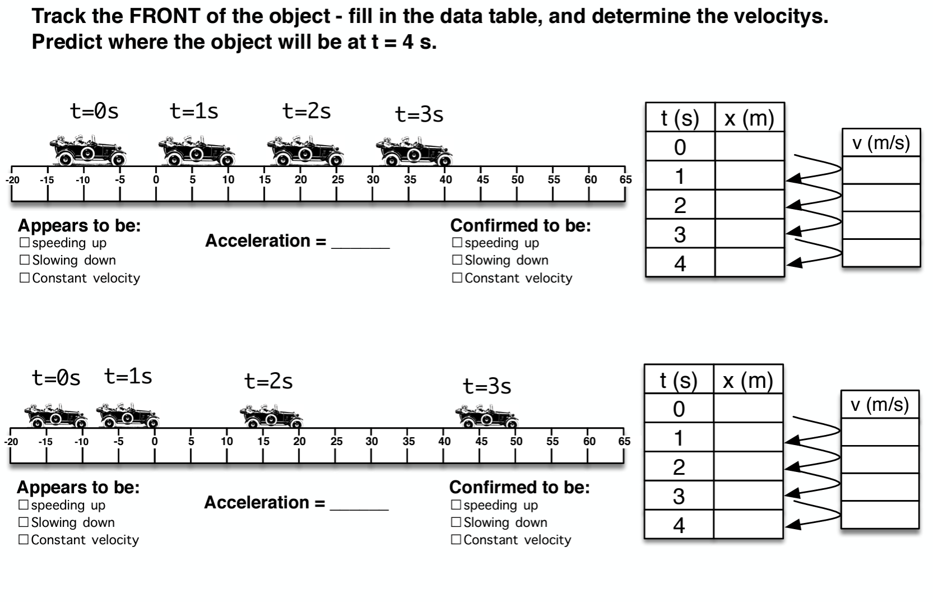

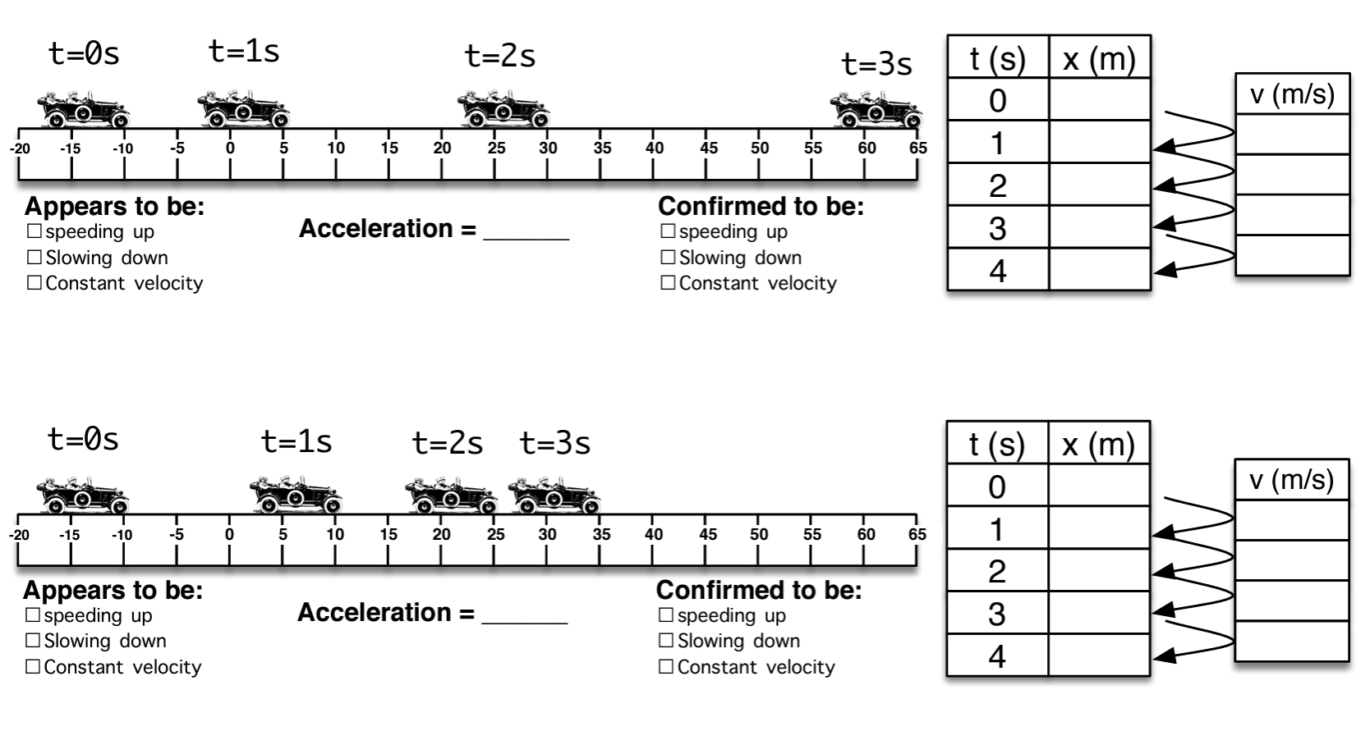

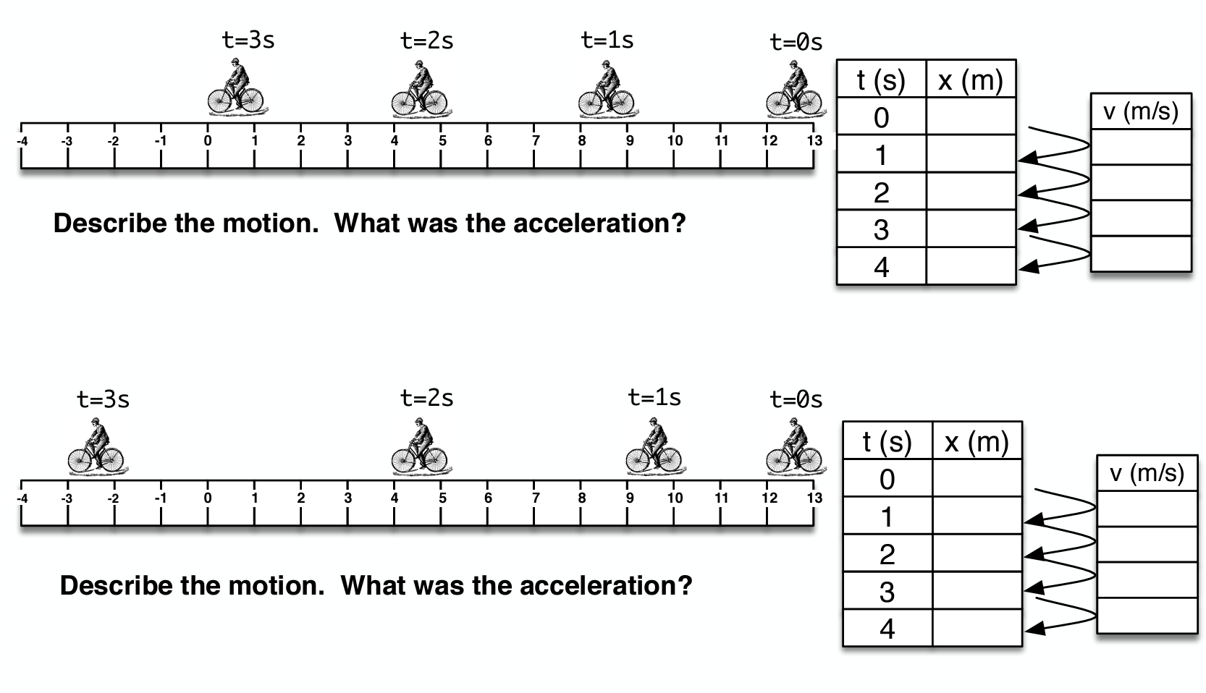

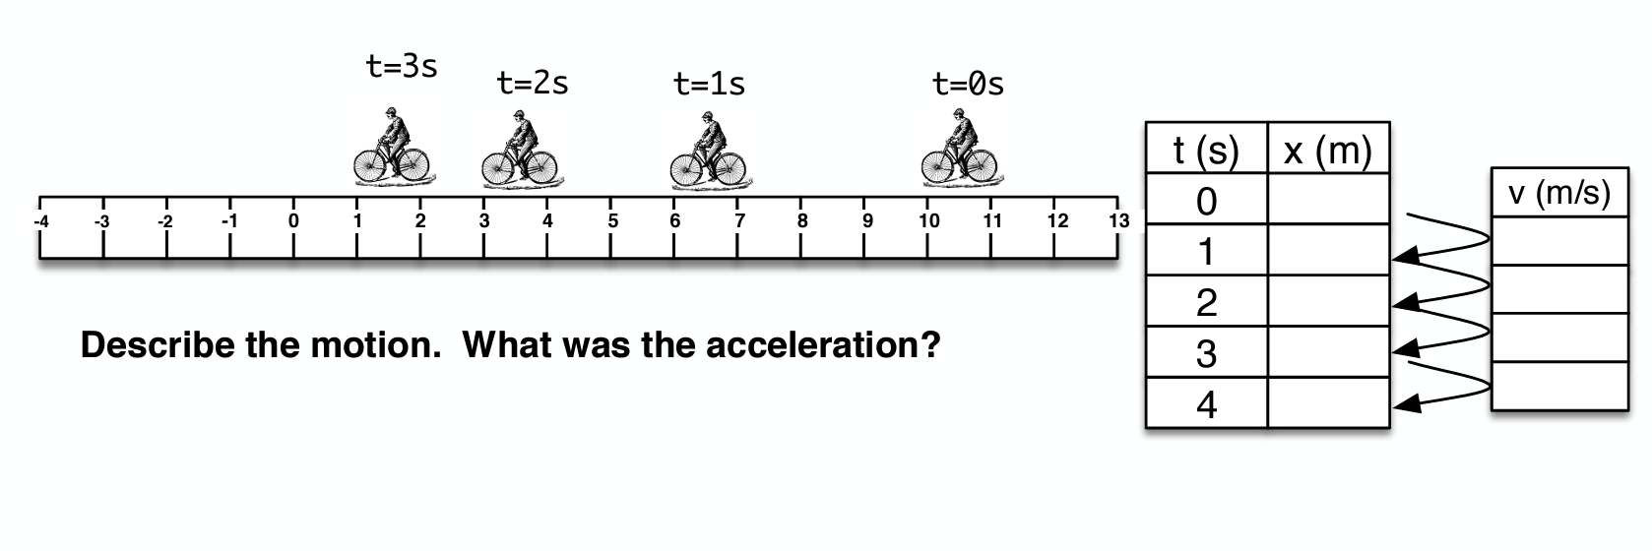

What is it about the velocity that tells us if it’s heading to the right or to the left?

Under what velocity/acceleration conditions does something speed up? Slow down?

