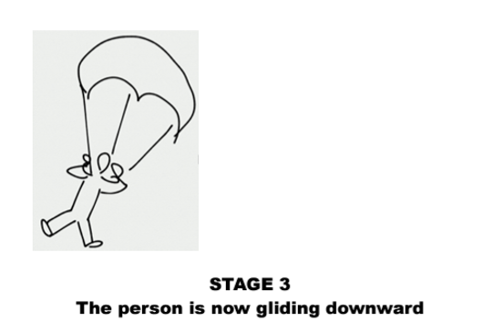
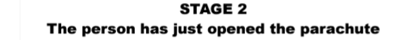
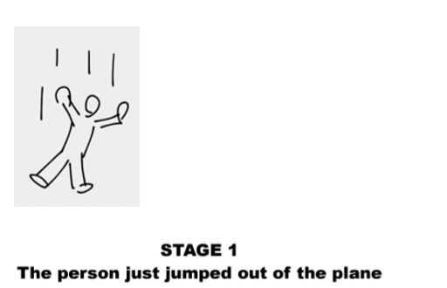
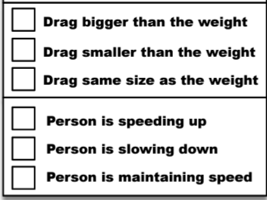
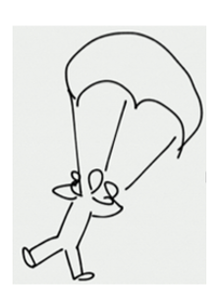
Skydiving
Consider dropping a basketball and a feather.



Which one reaches terminal velocity first? Why?

Which one has a faster terminal velocity? Why?
Yank!

NASA generally uses parachutes to land their spacecraft back onto Earth and land them in the ocean. However, during the mission to the Moon, they didn’t release their parachute to assist their landing on the Moon and resorted to using their rocket thruster to do so.


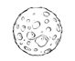
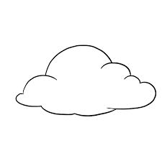

Why did they do this as opposed to just using the parachutes and saving some fuel?

Think of objects that experience…

A LOT of Drag | A little bit of Drag | Almost no Drag

