Name: _____________________
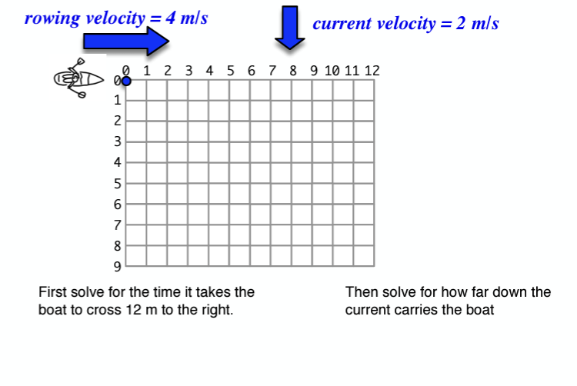

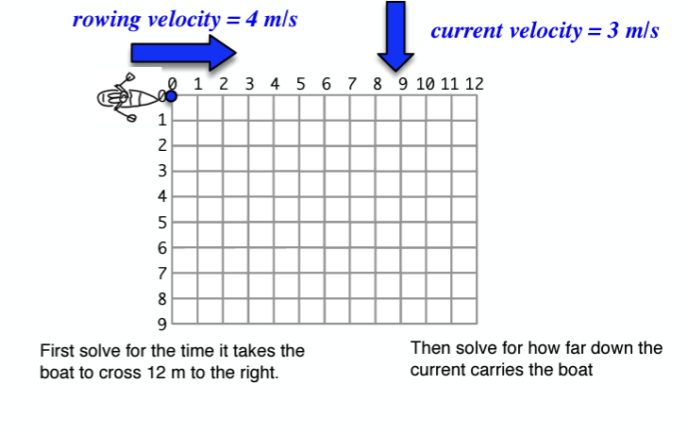

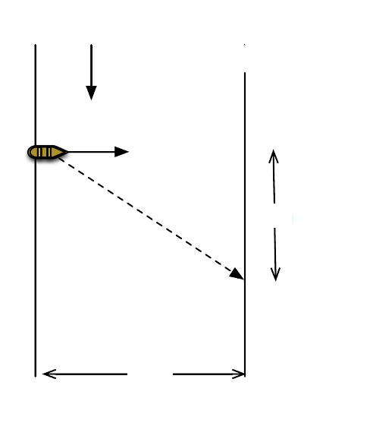
5 m/s
The boat is pointed straight across the river going at 10 m/s. The 5 m/s current carries it downstream and it crosses the river in 15 seconds.

- How wide is the river?

- How far down the river was the boat displaced?

10 m/s

? m

? m

4 m/s
The boat is pointed straight across the river. The 4 m/s current carries the boat downstream and the boat crossed the river in 15 seconds.

- How far down did the current take the boat?

- What is the velocity of the boat?

? boat

? m

90 m

