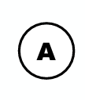
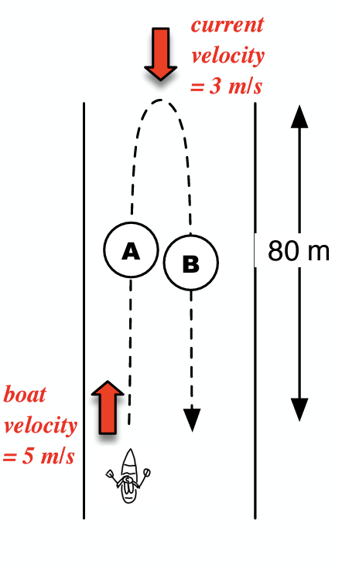
Name: _____________________
The boat travels 80 meters up the river against the current.

Resultant Velocity = ______________

How much time does it take to travel up the river?

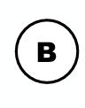
The boat travels 80 meters down the river with the current.

Resultant Velocity = ______________

How much time does it take to travel down the river?

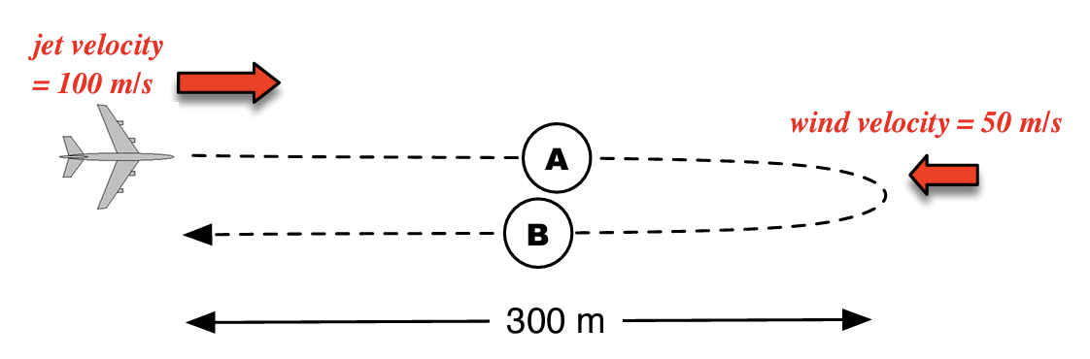

The jet travels 300 meters to the left with the wind.

Resultant Velocity = ______________

How much time does it take to travel 300 meters with the wind?
The jet travels 300 meters to the right against the wind.

Resultant Velocity = ______________

How much time does it take to take 300 meters against the wind?

