The current is 3 m/s towards the bottom of the paper. Draw the resultant current for each boat.
(Scale is 1 box = 1 m/s)

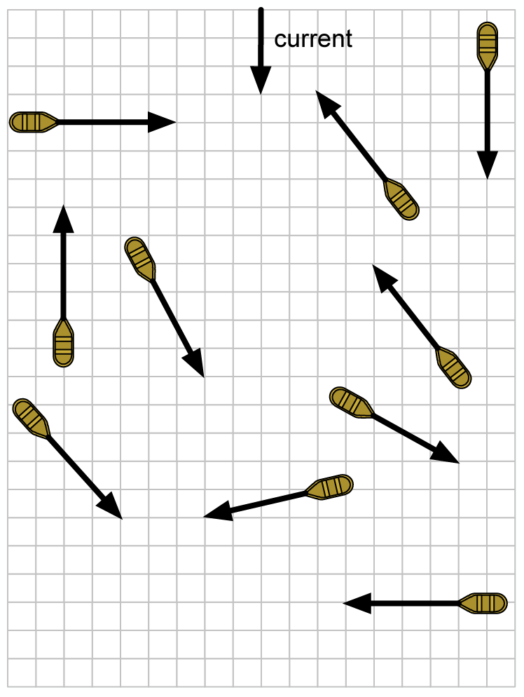

Airplane A flies East for 2 hrs. The other airplanes experience the wind directions shown.

