Recoil
- Why does recoil happen?

- What happens when a cannon is fired? Why don’t the cannonball and cannon get equal acceleration?

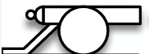

- What would happen if the cannon and the cannonball had equal masses?

Internal Forces

- If you push off something you’re attached to, what happens? Can you change speed or direction that way?

- To change speed or direction, what do you need?

- Why do astronauts tether themselves to the ISS on spacewalks?

- If an astronaut drifts away from the ISS with no tether, how could they get back?

