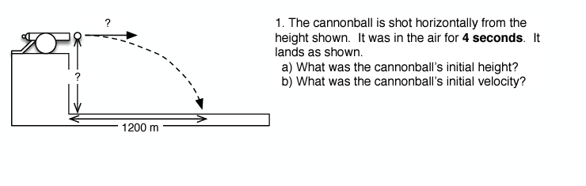
The cannonball is shot horizontally from the height shown. It was in the air for 4 seconds.

- What was the cannonball’s initial velocity?
- What was the cannonball’s initial height?
?

?

1200 m

The cannonball is shot horizontally from the height shown.

- How long was the cannon in flight for?
- What was the cannonball’s initial velocity?
?

20 m

54 m

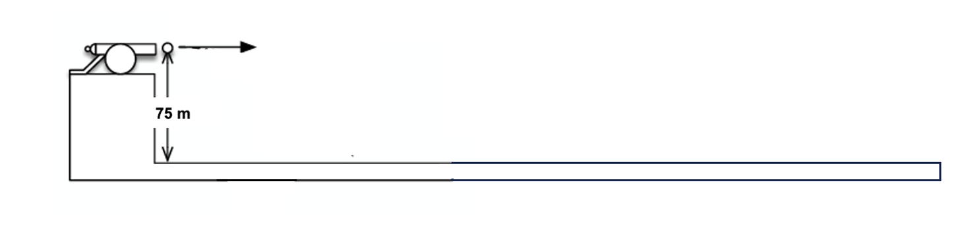
?

Pool A
Pool C
Pool B
125 m
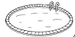
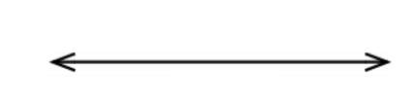
30 m
20 m
45 m
How fast does the cannonball need to be launched to land in…

- Pool A:

- Pool B:

- Pool C:

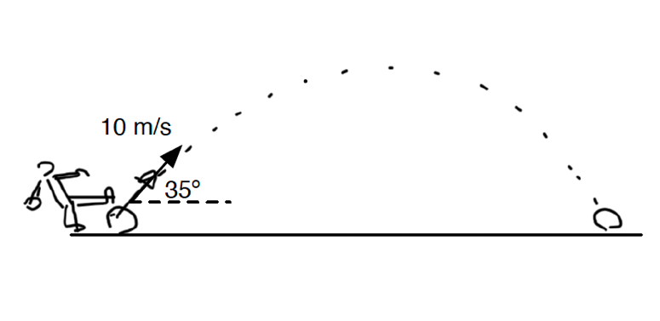
The soccer ball is kicked and lands at the same height.

- Resolve the velocity into its components.
- How long was the ball in flight?
- What horizontal distance did the ball travel?
- How high above the start height did the ball get?

