Name: ___________________

Normal Force:
In general, which direction does the normal force point?

Draw the normal force for the following.

Block B
Block A
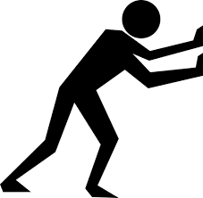
Block C
Surface
Surface
Surface

Person pushing

Frictional Force:
In general, which direction does the frictional force point?

Draw the frictional force for the following.
Stationary
Stationary

Block B
Block A
Block C
Surface
Surface
Surface

Is moving.
Person pushing

Challenging Problem:

Sketch a situation where the normal force points to the left ($←$) and the frictional force points down ($↓$)

