Example #1:
10 N
40 N

v

Mass = 20kg

Is moving.

This block is speeding up at 1 m/s/s.

Net Force | Direction ($F_{Net}$) | Frictional Force | Direction ($F_{F}$) | Static or Kinetic?

Example #2:

15 N

v
Mass = 10kg

Is moving.

This block is slowing down at 2 m/s/s.

Net Force | Direction ($F_{Net}$) | Frictional Force | Direction ($F_{F}$) | Static or Kinetic?
 |  | 25 N

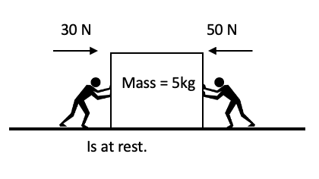
Net Force | Direction ($F_{Net}$) | Frictional Force | Direction ($F_{F}$) | Static or Kinetic?

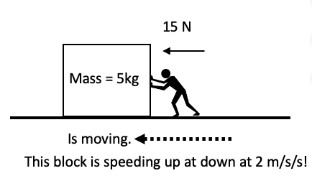
Net Force | Direction ($F_{Net}$) | Frictional Force | Direction ($F_{F}$) | Static or Kinetic?

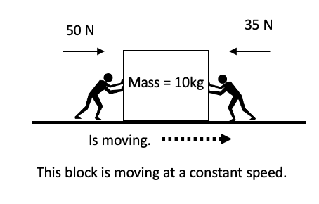
Net Force | Direction ($F_{Net}$) | Frictional Force | Direction ($F_{F}$) | Static or Kinetic?

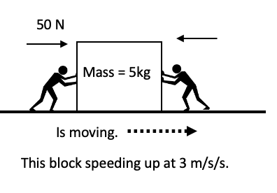
Net Force | Direction ($F_{Net}$) | Frictional Force | Direction ($F_{F}$) | Static or Kinetic?
 |  | 10 N

