Net forces with Accelerations B

Find all the unknowns!

Name: ______________________
15 N
10 N
Speed changes

Speed constant
Speed changes

Speed constant


Mass = 5kg
Mass = 5kg
40 N
30 N
v

$$F_{Net}$$ | Direction | Acceleration

$$F_{Net}$$ | Direction | Acceleration

50 N
50 N
Speed changes

Speed constant
20 N
60 N
Speed changes

Speed constant
v
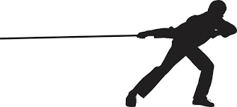
Mass = 40kg
v
Mass = 8kg

$$F_{Net}$$ | Direction | Acceleration

$$F_{Net}$$ | Direction | Acceleration

Speed changes

Speed constant
30 N
Speed changes

Speed constant
30 N

v
v
Mass = 10kg
Mass = 20kg

$$F_{Net}$$ | Direction | Acceleration
40 N

$$F_{Net}$$ | Direction | Acceleration
 |  | 1 m/s/s

Speed changes

Speed constant
40 N
35 N
Speed changes

Speed constant
v
v
Mass = 50kg
Mass = 5kg
$$F_{Net}$$ | Direction | Acceleration
15 N

$$F_{Net}$$ | Direction | Acceleration
10 N

