- Simply based on acceleration and velocity, how can you determine if…

- An object is moving at a constant velocity.
(Fill in numbers for velocity and acceleration that would match with this description)
v =
a =



- An object is speeding up.
(Fill in numbers for velocity and acceleration that would match with this description)
v =
a =

- An object is slowing down.
(Fill in numbers for velocity and acceleration that would match with this description)
v =
a =

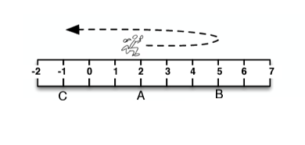

- The person runs from point A (x = 2 m) to point B (x = 5 m) in 4 seconds, then doubles back and ends up at point C (x = -1 m) in another 2 seconds.
- Calculate the average speed from A to C.

- Calculate the average velocity from A to C.

For each situation, track the FRONT of the car and fill in the boxes, the acceleration, and the table.
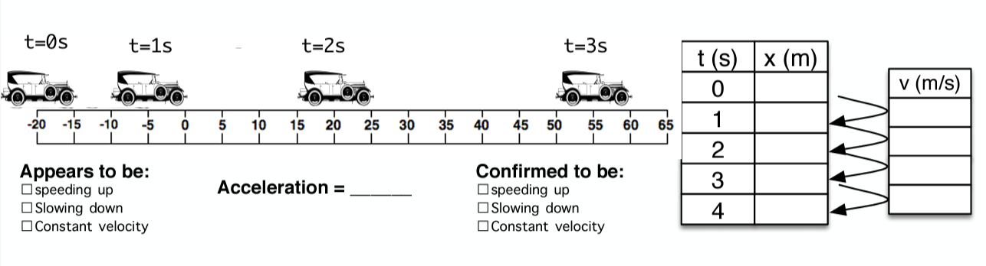

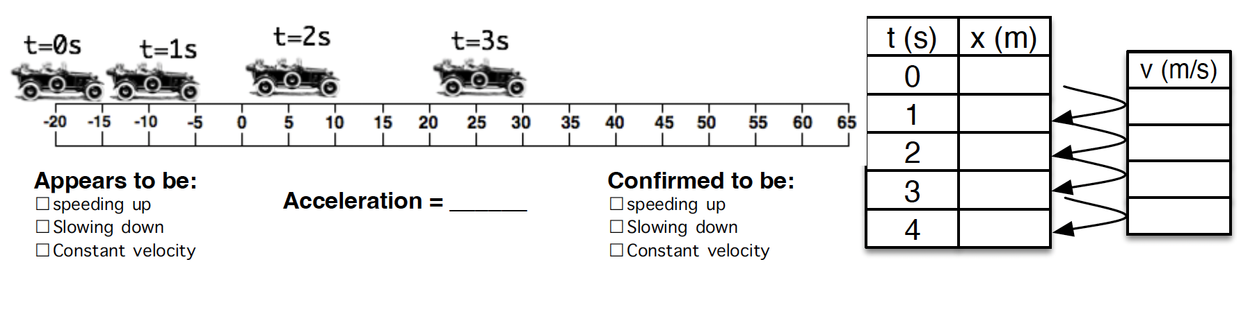

For each situation, track the FRONT of the person’s foot. Fill in the boxes based on the clues given about the person’s motion.
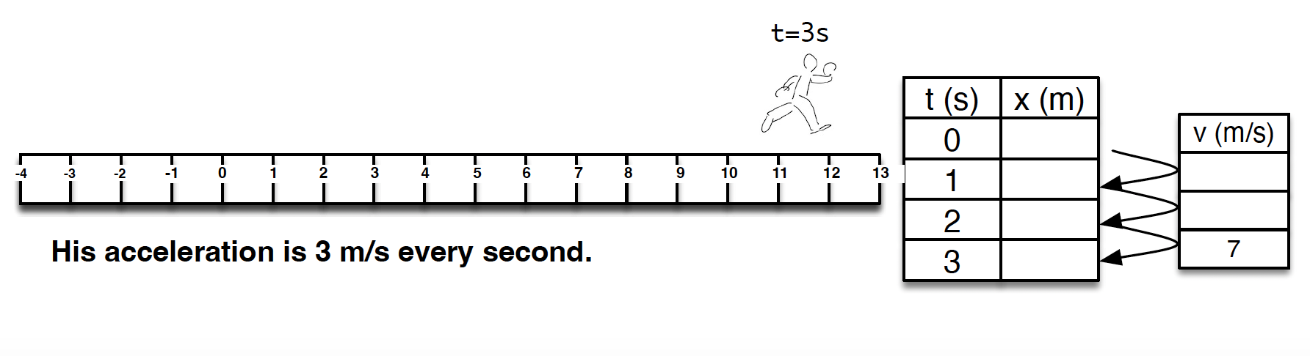

Acceleration = 3 m/s/s

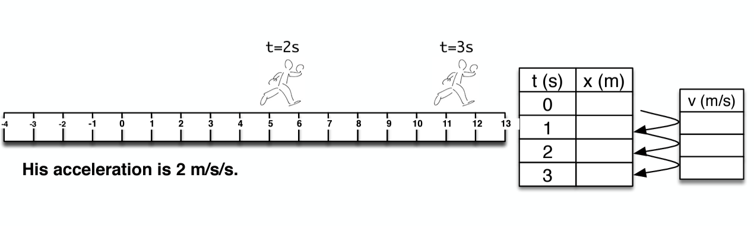

Acceleration = 2 m/s/s

