Name: __________________

- Motion involves changing your __________________________ over ___________________________

- What is a vector? Give an example.

- What is a scalar? Give an example.

- Calculate the average speed from A to B. The person runs from A to B in 4 seconds.

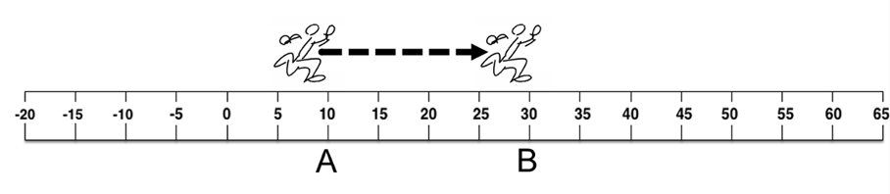

$$\frac{distance traveled}{elapsed time}=\frac{[_____________]}{[_____________]}=$$

- Calculate the average speed from A to C. The person runs from A to B in 4 seconds, but then immediately turns around and goes back to C in 6 seconds.
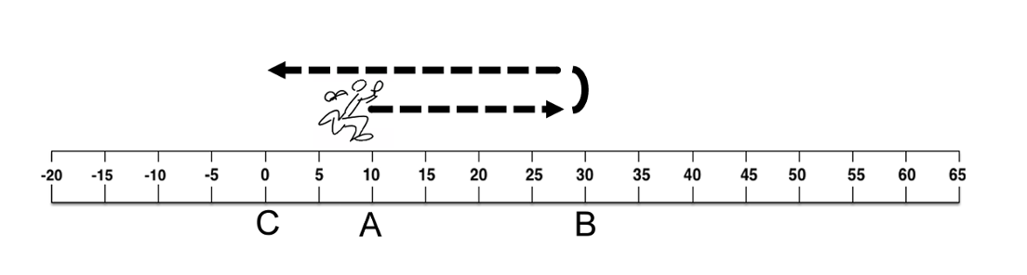

$$\frac{distance traveled}{elapsed time}=\frac{[__________+__________]}{[__________+__________]}=\frac{[_____________]}{[_____________]}=$$

- Calculate the average velocity from A to B. The person runs from A to B in 4 seconds.

Ending position
Starting position

$$\frac{change in position}{elapsed time}=\frac{[__________-__________]}{[__________]}=\frac{[_____________]}{[_____________]}=$$

- Calculate the average velocity from A to C. The person runs from A to B in 4 seconds, but then immediately turns around and goes back to C in 6 seconds.

Starting position
Ending position

$$\frac{change in position}{elapsed time}=\frac{[__________-__________]}{[__________+__________]}=\frac{[_____________]}{[_____________]}=$$


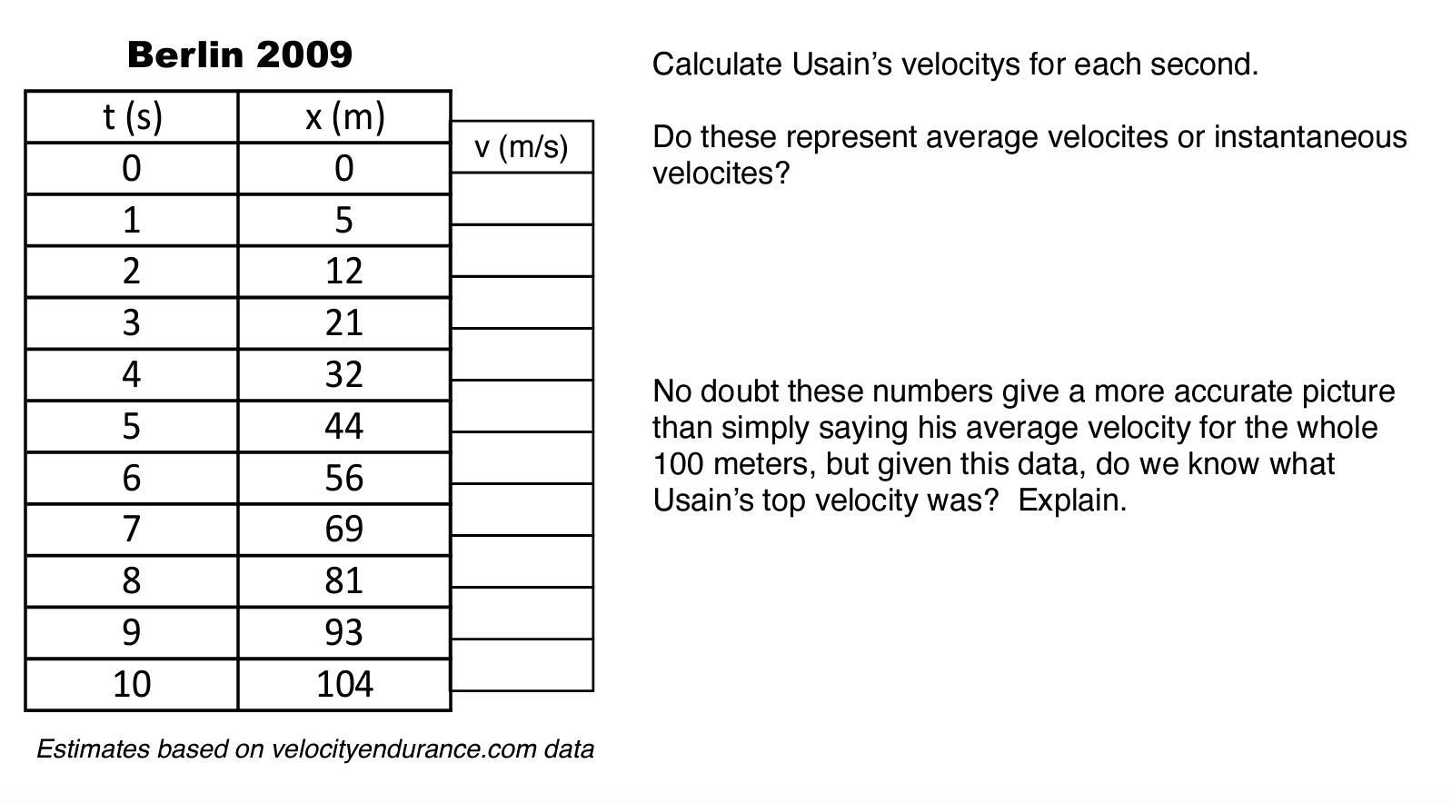

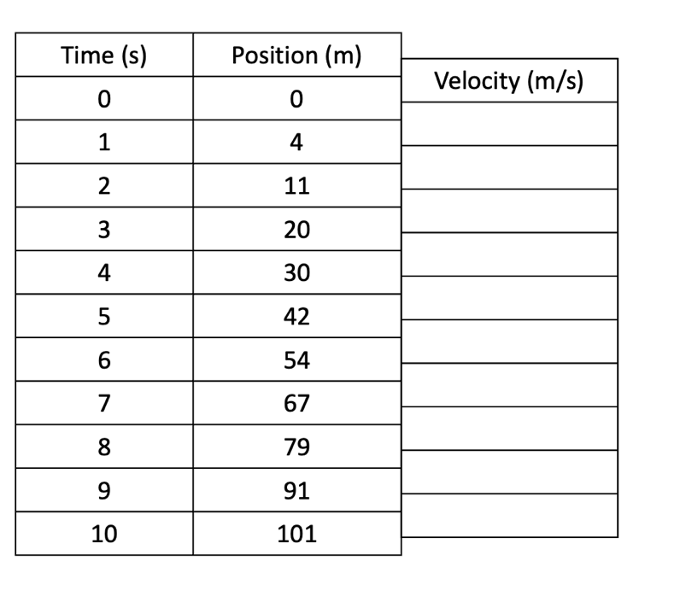

- How is an instantaneous velocity and instantaneous speed different from an average velocity and average speed?

- Under what circumstances would the average speed and average velocity be the same? Under what circumstance would they be different?

- The person runs from point A (x = -1 m) to point B (x = 5 m) in 4 seconds, then doubles back and ends up at point C (x = 2 m) in another 2 seconds.
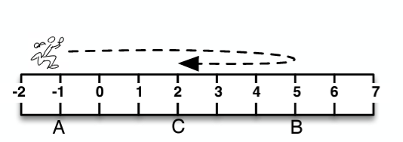
- Calculate the person’s average speed from A to C.
- Calculate the person’s average velocity from A to C.

- The person runs from point A (x = 5 m) to point B (x = 2 m) in 3 seconds, then doubles back and runs to point C (x = 4 m) in 2 seconds, then turns around again and ends up at point D (x = -1 m) in another 3 seconds.

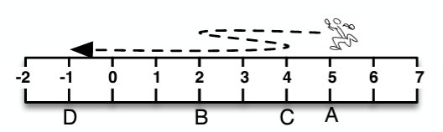
- Calculate the person’s average speed from A to D.
- Calculate the person’s average velocity from A to D.

