More Kinematics
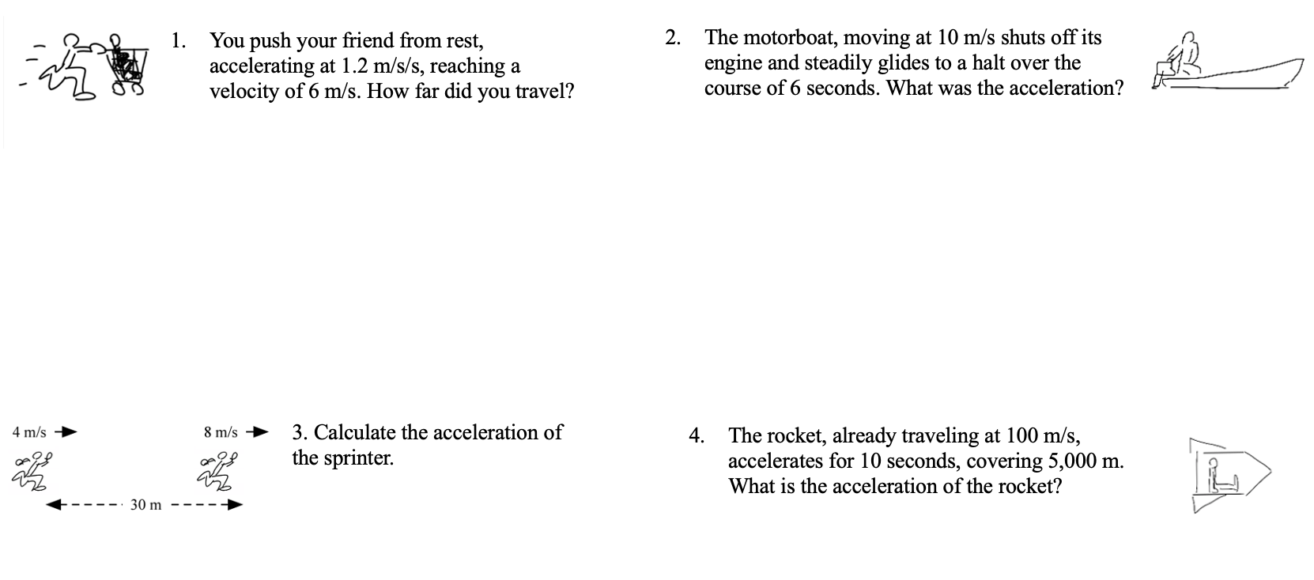

More Kinematics
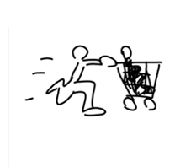
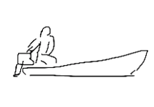
- You push your friend from rest, accelerating at 1.2 m/s/s, reaching a velocity of 6 m/s. How far did you travel?
- The motorboat, moving at 10 m/s shuts off its engine and steadily glides to a halt over the course of 6 seconds. What was the acceleration?

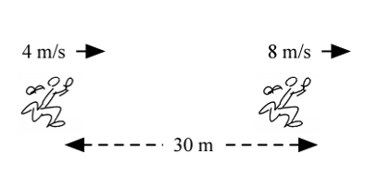

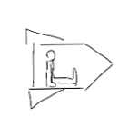
- The rocket, already traveling at 100 m/s, accelerates for 10 seconds, covering 5,000 m. What is the acceleration of the rocket?
3. Calculate the acceleration of the sprinter.

