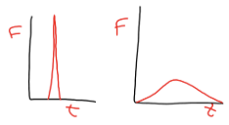
How is the Impulse represented on a Force vs. Time graph?

When you bend your knees landing from a jump, the average person would say “Your knees absorb the force”. What is the real explanation?

If a car crashes into a wall, what will happen to the force of the car if the time of impact is tripled?

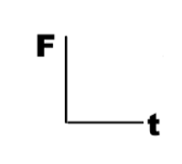
For each pair of situations, sketch out what a Force vs. Time graph would look like.
I caught a fastball without a glove.
I caught a fastball with a glove.
Vs.

Someone faints and falls.
An experienced stunt person lands from a fall.
Vs.

The front end of new cars when crashing.
The front end of old cars when crashing.
Vs.

