
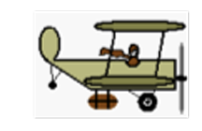
Name: ___________________
1600 m

This pilot (who clearly has no physics experience) wants to drop you a package when directly overhead. The package lands 8 seconds later and you must walk 1600m to get it.

- Assuming the airplanes velocity was horizontal, what was its velocity?

- What was the airplanes altitude?

