Name: _________________
Free Fall Kinematics A
(Assume minimal drag.)
- If you drop a ball off a 45-meter-tall building, how long before it hits the ground?



45 m

- If you drop a ball off a canyon and it hits the ground 5.2 seconds later, how tall is the canyon?
(Assume minimal drag.)
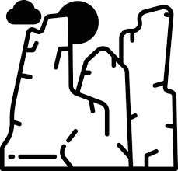
5.2 s

Name: ___________________
Free Fall Kinematics B
(Assume minimal drag.)
- If you drop a ball off a 65-meter-tall building, how long before it hits the ground?

65 m

- If you drop a ball off a canyon and it hits the ground 3.5 seconds later, how tall is the canyon?
(Assume minimal drag.)
3.5 s

