Escape Jurassic Park (physics style)
Escape Jurassic Park (physics style)

Role #1: Person
- Moves are from the middle of one square to the middle of another.
- You many move four squares per turn in any combination of directions, NOT diagonal!
- After you move, the two T-Rexes will move two squares for their turn in any combination of directions, NOT diagonal!
- If the T-Rexes catch you, you get eaten and lose (game over!)
- You must escape within 15 turns!
- Keep track of your VECTORS on the table below!

Role #1: Person
- Moves are from the middle of one square to the middle of another.
- You many move four squares per turn in any combination of directions, NOT diagonal!
- After you move, the two T-Rexes will move two squares for their turn in any combination of directions, NOT diagonal!
- If the T-Rexes catch you, you get eaten and lose (game over!)
- You must escape within 15 turns!
- Keep track of your VECTORS on the table below!

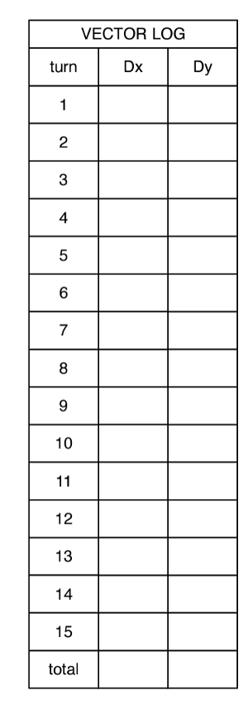

Escape Jurassic Park (physics style)
Escape Jurassic Park (physics style)

Role #2: T-Rex
- You can start wherever you’d like, but NOT in the square highlights in “START (person)”
- Moves are from the middle of one square to the middle of another.
- You many move two squares per turn in any combination of directions, NOT diagonal!
- After you move, the person will move four squared in any direction, NOT diagonal!
- If you or your T-Rex partner catch the person, you get to eat them and win!
- If the person doesn’t escape within 15 turns, you also win!
- You may NOT enter the “Safe Zone.”
- Keep track of your VECTORS on the table below!

Role #2: T-Rex
- You can start wherever you’d like, but NOT in the square highlights in “START (person)”
- Moves are from the middle of one square to the middle of another.
- You many move two squares per turn in any combination of directions, NOT diagonal!
- After you move, the person will move four squared in any direction, NOT diagonal!
- If you or your T-Rex partner catch the person, you get to eat them and win!
- If the person doesn’t escape within 15 turns, you also win!
- You may NOT enter the “Safe Zone.”
- Keep track of your VECTORS on the table below!

