Name: ______________________

What is the standard definition of the Third Law of Motion?

What is a better definition of the Third Law of Motion?

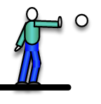
- When a person throws a ball, you might not see them go backwards. Why not? Is it because they do not get a force back?

- Why are force pairs more noticeable in zero-g?

- If two objects collide and you see them get equal and opposite accelerations, what does that mean about their masses?

- If two objects collide and they don’t get equal and opposite accelerations, what does that mean about their masses? Does it mean that the forces weren’t equal and opposite?

- A big truck and a small truck collide, which one gets a bigger force?

