Name: _________________________

What are the 3 main states of matter? (There are technically 4, but the 3 most common on Earth)

Two people go outside on a windy day. Both hold up pieces of cardboard, one large and one small. Who feels more drag from the air? _____________________________________________________________________
What is it that affects drag here?

Two more people go outside on a windy day. Both hold up pieces of cardboard, one curved outward, and one flat. Who feels more drag from the air? __________________________________________________________
What is it that affects drag here?

Two people are outside moving. One walks and holds their hand up, the other is driving and holds their hand up. Who feels more drag from the air on their hand? ______________________________________________
What is it that affects drag here?

Someone is running on the track. Someone else is running through water. Finally, someone is running through a pool of syrup! Who feel more drag? ___________________________________________________________
What is it that affects drag here?

How is drag different from friction?

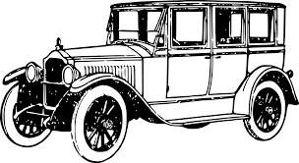
A
Cars used to look like the image A, while more recent cars take on a design that looks more like image B.

Why do you think they changed? How is this related to drag?

B

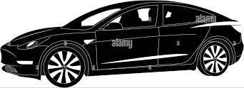

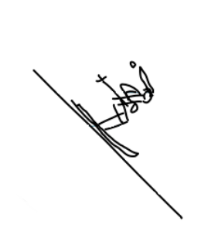

While going down a hill, skiers will often crouch down as shown to the left.

Why do they do this? How is this related to drag?

The average person might think that heavier objects fall faster, but they’re probably thinking about dropping a ball and piece of paper.

Is this a fair test? Why or why not?

