Name: ______________________

Look at the graphs below and graph the dot pattern in the horizontal “x” direction and the vertical “y” direction on the lines present to the right of the graph. Using this information, determine which direction is experiencing an acceleration!

$$y:$$
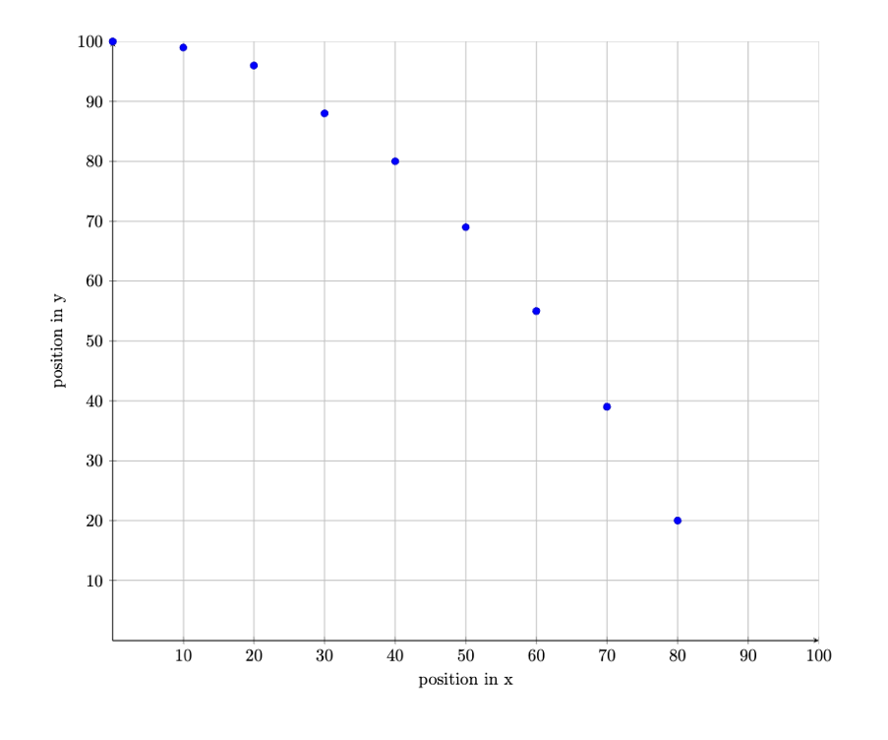
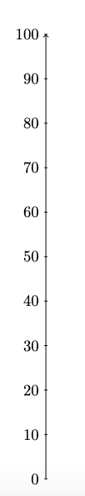

Which direction is experiencing an acceleration?

___________________

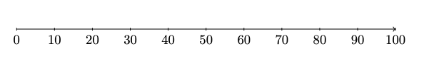
$$x:$$

$$y:$$
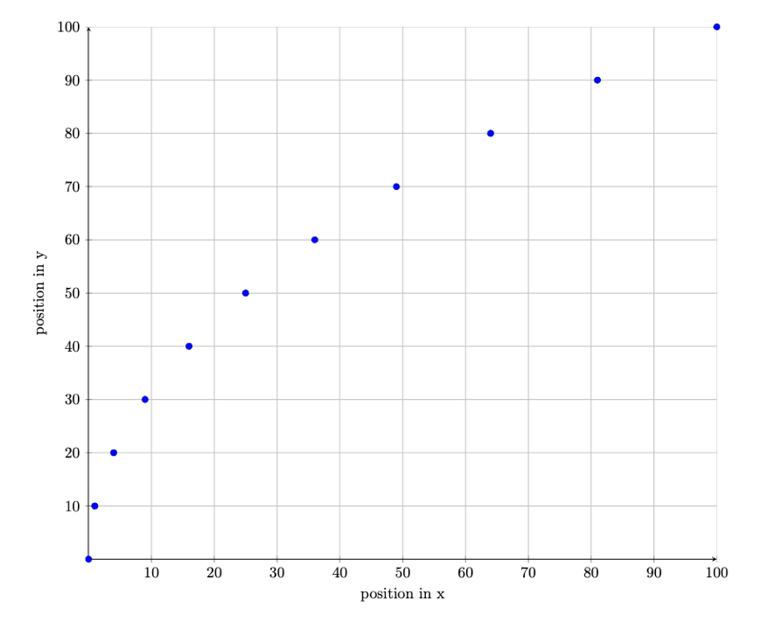

Which direction is experiencing an acceleration?

___________________

$$x:$$
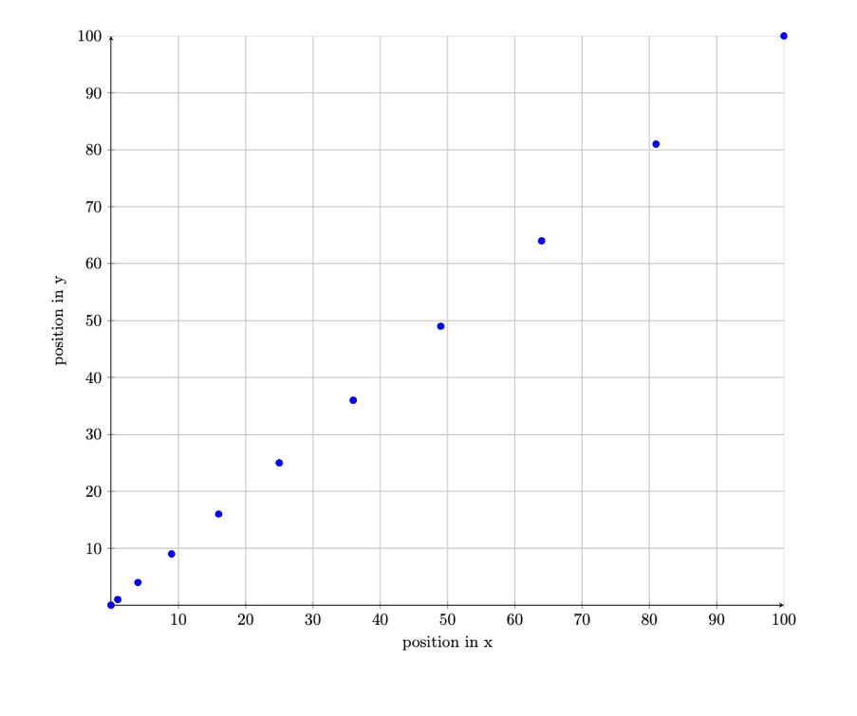
$$y:$$

Which direction is experiencing an acceleration?

___________________

$$x:$$
5

$$y:$$
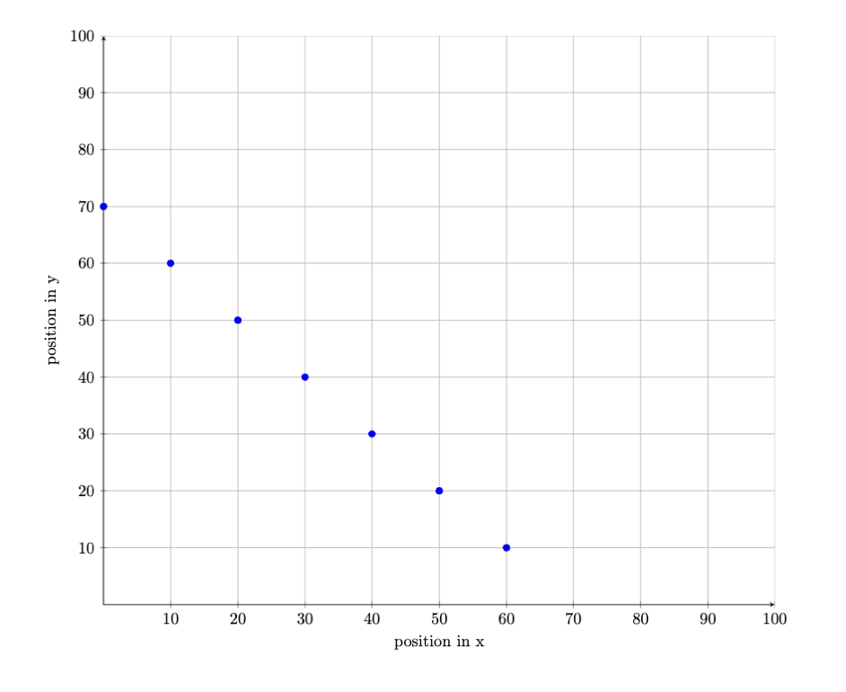

Which direction is experiencing an acceleration?

___________________

$$x:$$

