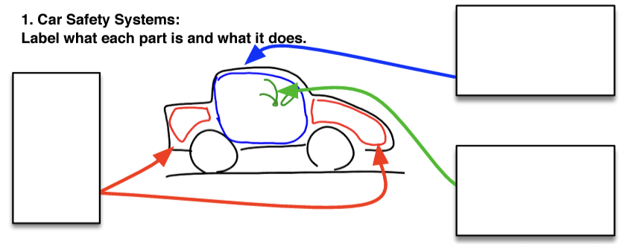

2. List three dangers of driving older cars

3. Go to ‘Cox Physics’ and look at the crash test clips of the 1996 Ford Aerostar and the 2024 Acura Integra

- What about the crumple zone of the 1996 Ford Aerostar and the 2024 Acura Integra are different?

4. On ‘Cox Physics’ go to “Vehicle Safety Ratings” and look up the safety ratings of each car.

- What are the safety ratings of the 1996 Ford Aerostar?

- What are the safety ratings of the 2024 Acura Integra?

5. Based on what we learned about Impulse, why do you think the safety ratings of the two cars above are so different?

