Name: _____________________
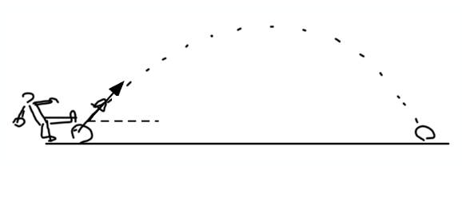
The soccer ball is kicked from and lands at the same height.

- Solve for Vx and Vy.
- How long was the ball in flight?
- What horizontal distance did the ball travel?
- What was its maximum height above the launch point?
15 m/s

$${25}^{°}$$

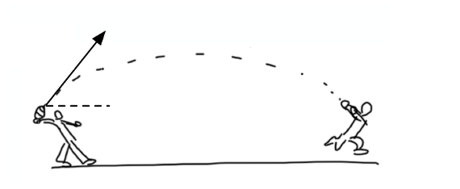
The football is thrown from and caught at the same height.

- Solve for Vx and Vy.
- How long was the ball in flight?
- What horizontal distance did the ball travel?
- What was its maximum height above the launch point?
21 m/s

$${55}^{°}$$

