Name: ______________________

What is the Tension force on rope 1 if the Tension force on rope 2 is 1500N, and this person is not accelerating?

rope 2

$${25}^{°}$$
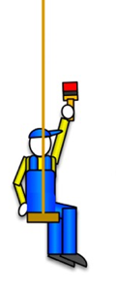
rope 1

What is the coefficient of friction if this 650 kg car is at rest and staying at rest on this incline?

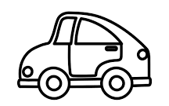

$${35}^{°}$$

